Join Your Myrtle Beach Penn State Alumni Association Friends in 2020
For our 3rd Winter Cruise On Board Royal Caribbean’s HARMONY OF THE SEAS
Eastern Caribbean Itinerary - 7 Nights Departing January 26, 2020
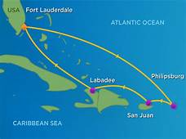

Itinerary:
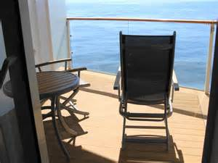
Jan 26 Orlando (Port Canaveral) Depart 4:30 pm
Jan 27 Cruising
Jan 28 Cruising
Jan 29 Philipsburg, St Maarten 8 am – 5 pm
Jan 30 San Juan, Puerto Rico 7 am – 4 pm
Jan 31 Cruising
Feb 1 Perfect Day Cococay, Bahamas 8 am – 5 pm
Feb 2 Orlando (Port Canaveral Dock 6 am
Ocean View Balcony $1157.66 - $1189.66 per person
Includes all taxes and fees • Gratuities are $101.50 per person if you choose to include them
Current Offers Will Apply • $500 per cabin refundable deposit
573-446-6446
Prices are per cabin based on double occupancy. All itineraries and prices are subject to change without notice. © 2014 Royal Caribbean Cruises Ltd. Ships registry: The Bahamas. Brilliance of the Seas is operated by RCL (UK) Ltd. Subsidiary of Royal Caribbean Cruises Ltd.

