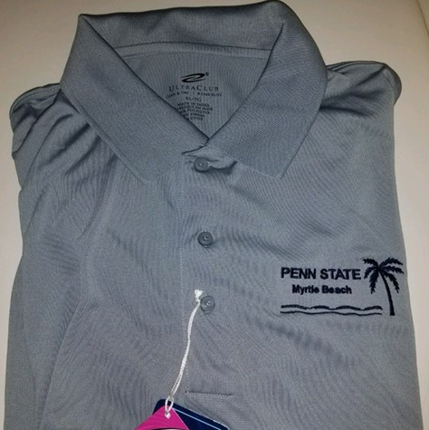
Official Chapter Apparel
With
Myrtle Beach Chapter Logo
Now on Sale

We Are...now offering Myrtle Beach Chapter Apparel for our fans and members! You can order your own specialty clothing with our Myrtle Beach Chapter logo. Simply fill out the attached order form and mail it with you check.
-----------------------------------detach here and return the form below with your payment---------------------------
Clothing currently available in White(W) or Gray (G) and Navy Blue (N)
No. Men’s Sizes Size and Color Size and Color
Tee Small – XL ($15) 2XL–3XL ($18)
Golf Polo Small – XL ($22) 2XL–3XL ($25)
Drifit Golf Polo Small – XL ($25) 2XL–3XL ($28)
Hoodie Small= XL($25) 2X –3XL ($28)
Sweat Pants Small= XL($22) 2X –3XL ($25)
Long Sleeve Tee Small= XL($17) 2X –3XL($20)
Women’s Sizes
Tee XS – XL ($15) 2X –3XL ($18)
V- Neck XS – XL ($17) 2X –3XL ($20)
Golf Polo XS – XL ($22) 2X –3XL ($25)
Hoodie Small= XL($25) 2X –3XL ($28)
Sweat Pants Small= XL($22) 2X –3XL ($25)
Long Sleeve Tee Small= XL($17) 2X –3XL($20)
Please allow 2-3 weeks for order processing
Name: ______________________________________________________ Phone: _____________________
Address: _________________________________________________________________________________
City: ________________________________________ State: ________ Zip: ______________________
E-mail address: _______________________________________ Enclosed is my check for $____________
Mail with check payable to Myrtle Beach Chapter Penn State Alumni to: Paula Brown, 3018 Chesterwood Ct., Myrtle Beach, SC 29579

